David Philipps

**From Wikipedia, the free encyclopedia**

https://en.wikipedia.org/wiki/David%20Philipps  
Licensed under CC BY-SA 3.0:  
https://en.wikipedia.org/wiki/Wikipedia:Text_of_Creative_Commons_Attribution-ShareAlike_3.0_Unported_License

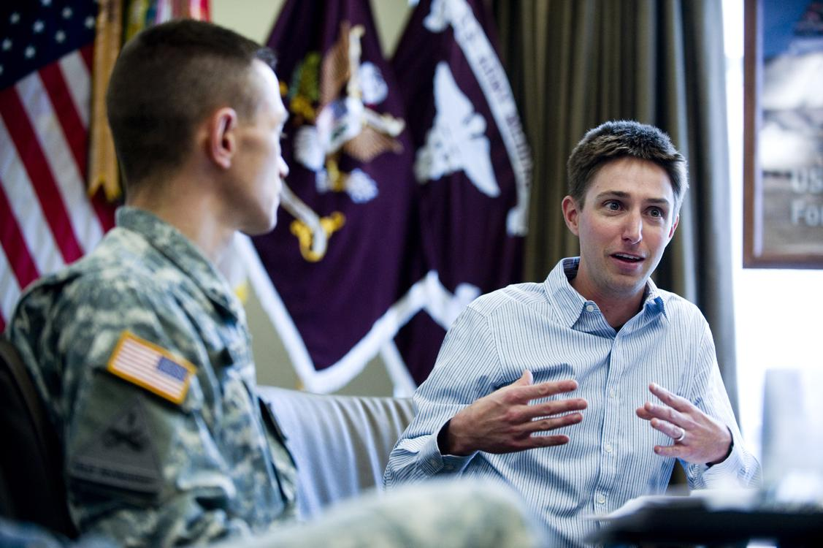  
*Journalist David Philipps interviews medical personnel at Fort Carson in 2013*

# David Philipps

* *He is a national correspondent for the New York Times and is the author of two books.*
* *At the New York Times, Philipps covers the military, veterans and breaking news.*
* *The second was the 2017 Pulitzer Prize for breaking news, which he shared with the New York Times staff for coverage of a mass shooting in Las Vegas.*

David Nathaniel Philipps, born in 1977, is a Pulitzer Prize-winning American journalist and author whose work has largely focused on the human impact of the wars in Iraq and Afghanistan. He is a national correspondent for the New York Times and is the author of two books. The most recent is Wild Horse Country.

At the New York Times, Philipps covers the military, veterans and breaking news.

Philipps won a Pulitzer Prize for National Reporting in 2014 for his three-day series "Other Than Honorable" in The Gazette of Colorado Springs on the treatment of injured American soldiers being discharged without military benefits. He has also been named a finalist for the Pulitzer Prize twice. The first was the 2010 Pulitzer Prize for local reporting, which cited "his painstaking stories on the spike in violence within the Band of Brothers, a battered combat brigade returning to Fort Carson after bloody deployments to Iraq, leading to increased mental health care for soldiers." The second was the 2017 Pulitzer Prize for breaking news, which he shared with the New York Times staff for coverage of a mass shooting in Las Vegas.

Philipps won the 2009 Livingston Award for his reporting on violence in infantry troops returning from Iraq. His book, Lethal Warriors chronicles how the 4th Brigade Combat Team of the 12th Infantry Regiment, stationed at Fort Carson, Colorado, produced a high number of murders after soldiers returned from unusually violent combat tours. Philipps worked for eight years as an enterprise reporter at the Colorado Springs Gazette.

Philipps has written extensively about wild horses in the West, and gained attention in 2012 when U.S. Secretary of Interior Ken Salazar threatened to punch him while Philipps was asking about troubles in the department's wild horse program. Philipps' subsequent reporting led to state and federal investigation of the wild horse program and its largest horse buyer. His latest book, Wild Horse Country, traces the culture and history that created modern wild horse management. Philipps' writing on wild horse management has faced criticism as being based on unsound science.

Philipps graduated from Middlebury College in 2000 and earned a master's degree from the Columbia University Graduate School of Journalism in 2002.

# Notable work

* *"In unit stalked by suicide, members try to save one another" ," The New York Times, Sept. 19, 2015*
* *"Wounded Warrior Project Spends Lavishly on Itself " The New York Times, January 27, 2016*
* *"A Marine Attacked an Iraqi Restaurant, But was it a Hate Crime or PTSD" ," The New York Times, Oct. 18, 2017*
* *"Other than Honorable," The Colorado Springs Gazette, May 19, 2013*

"A Marine Attacked an Iraqi Restaurant, But was it a Hate Crime or PTSD" ," The New York Times, Oct. 18, 2017

"Wounded Warrior Project Spends Lavishly on Itself " The New York Times, January 27, 2016

"In unit stalked by suicide, members try to save one another" ," The New York Times, Sept. 19, 2015

"Other than Honorable," The Colorado Springs Gazette, May 19, 2013

"Casualties of War," The Colorado Springs Gazette, July 28, 2009.

"All the missing horses," ProPublica, Sept. 28, 2012

"Honor and Deception," The Colorado Springs Gazette, Dec. 1, 2013

# References